SMART HOSPITAL ANALYTICS DASHBOARD
Abstract
Healthcare organizations generate large volumes of operational data every day, including patient admissions, waiting times, doctor availability, bed occupancy, treatment duration, and patient satisfaction. Analyzing this information helps hospitals improve operational efficiency, reduce waiting times, optimize resource utilization, and enhance patient care.
This project presents a Smart Hospital Analytics Dashboard developed using Python (Google Colab) for data preprocessing and Power BI for interactive dashboard visualization. The project follows four phases: Data Understanding & Cleaning, KPI Design, Analytics Investigation, and Dashboard Development. Key Performance Indicators (KPIs) such as Total Patients, Average Waiting Time, Bed Utilization Rate, Patient Satisfaction Score, Emergency Cases, Appointment Delay Percentage, Department Performance, and Revenue Generated are analyzed to provide actionable insights.
The dashboard enables hospital administrators to monitor patient flow, identify operational bottlenecks, evaluate department performance, and make data-driven decisions to improve healthcare services.
Keyword
- Healthcare Analytics
- Hospital Dashboard
- Business Intelligence
- Power BI
- Python
- Data Analytics
- KPI Dashboard
- Patient Flow Analysis
- Hospital Operations
- Operational Intelligence

1. Introduction
- Healthcare organizations manage thousands of patient records every day. These records contain valuable information about patient admissions, waiting times, treatment duration, doctor availability, emergency visits, hospital revenue, and patient satisfaction. Without proper analysis, hospitals may experience long waiting times, bed shortages, staff overload, reduced patient satisfaction, and inefficient resource utilization.
- The objective of this project is to develop a Smart Hospital Analytics Dashboard that transforms hospital operational data into meaningful insights. By integrating data preprocessing with interactive dashboards, hospital management can monitor hospital performance, identify operational bottlenecks, improve patient flow, optimize resource allocation, and enhance the overall patient experience.
- The dashboard provides an easy-to-understand visualization of important hospital metrics, enabling administrators to make informed decisions based on real-time operational data.
2. Project Objectives
The main objectives of this project are:
- To understand and clean the hospital dataset.
- To preprocess healthcare operational data for analysis.
- To create meaningful derived features.
- To design operational healthcare KPIs.
- To analyze patient flow and hospital performance.
- To identify operational bottlenecks.
- To visualize hospital performance using interactive dashboards.
- To provide business recommendations for improving hospital operations.
3. Dataset Description
- The dataset used in this project is a synthetic hospital operational dataset containing approximately 3,000 patient records. It includes information related to hospital operations, patient demographics, appointments, treatment details, financial performance, and service quality. This type of dataset is suitable for analyzing hospital efficiency and patient experience.
- TASK_DA_02
- Dataset Columns
Column | Description
Patient_ID | Unique patient identifier
Admission_Date | Patient admission date
Admission_Time | Patient admission time
Department | Hospital department
Doctor | Assigned doctor
Age | Patient age
Gender | Patient gender
Visit_Type | Type of visit
Emergency | Emergency case status
Waiting_Time_Min | Waiting time in minutes
Appointment_Delay | Appointment delay
Bed_Assigned | Bed allocation status
Treatment_Time_Min | Treatment duration
Length_of_Stay_Days | Hospital stay duration
Revenue | Revenue generated
Satisfaction_Score | Patient satisfaction score
Payment_Mode | Payment method
Outcome | Treatment outcome
Service_Quality | Quality of service
Shift | Hospital shift
Project Methodology
This project follows a structured data analytics methodology to transform raw hospital operational data into meaningful business insights. The methodology consists of four major phases: Data Understanding & Cleaning, KPI Design, Analytics Investigation, and Dashboard Development. Initially, the hospital dataset was imported into Google Colab for preprocessing. The data was cleaned by handling missing values, removing duplicate records, converting date and time fields, and creating derived features. After preprocessing, healthcare Key Performance Indicators (KPIs) were designed to measure hospital efficiency and patient experience. Analytical investigations were then performed to identify trends, operational bottlenecks, and resource utilization. Finally, an interactive Power BI dashboard was developed to visualize hospital performance and support data-driven decision-making. This structured approach ensures accurate analysis and effective presentation of healthcare insights.
Project Workflow

Hospital Dataset
↓
Data Understanding
↓
Data Cleaning & Feature Engineering
↓
KPI Design
↓
Analytics Investigation
↓
Dashboard Development (Power BI)
↓
Business Insights & Recommendations
PHASE 1 – DATA UNDERSTANDING & CLEANING
The first phase of this project focused on preparing the hospital dataset for analysis. Data preprocessing is a critical step because the quality of insights depends on the quality of the data. During this phase, the dataset was examined to understand its structure, identify missing values, remove duplicate records, convert date and time fields into the appropriate format, and create additional derived features. These preprocessing steps improved the reliability and consistency of the dataset, making it suitable for healthcare analytics and dashboard development.
Loading the Dataset
The hospital dataset was imported into Google Colab using the Python Pandas library. After loading the dataset, the first few rows were displayed to verify that the data had been imported successfully. The dataset consisted of approximately 3,000 patient records with information related to patient admissions, doctor allocation, department details, waiting time, treatment duration, revenue, patient satisfaction, and hospital operations.
Understanding the Dataset
The dataset was explored using functions such as head(), info(), describe(), and columns. These functions helped identify the number of records, available variables, data types, numerical summaries, and the overall structure of the dataset. Understanding the dataset was essential before performing any preprocessing tasks.
Handling Missing Values
The dataset was checked for missing values using the isnull() function. Missing values, if present, were handled appropriately to ensure data consistency and avoid incorrect analytical results. This step improved the completeness and reliability of the dataset.
Removing Duplicate Records
Duplicate records were identified using the duplicated() function and removed using the drop_duplicates() function. Eliminating duplicate entries ensured that each patient record appeared only once in the dataset, preventing inaccurate calculations during analysis.
Date and Time Conversion
The Admission_Date column was converted into the datetime format, and the Admission_Time column was converted into a standard time format. This conversion enabled trend analysis, patient admission analysis, and peak-hour analysis in the Power BI dashboard.
Creating Derived Features
To enhance analytical capabilities, several new features were created from the existing dataset.
Waiting Category
Patients were classified into four categories based on their waiting time:
- Low
- Medium
- High
- Critical
This categorization helps identify patients experiencing longer waiting periods and supports better operational planning.
Department Load
A new feature called Department Load was created by counting the number of patients assigned to each department. This metric helps identify departments with high patient volume and resource demand.
Bed Utilization
A bed utilization metric was created using the Bed_Assigned column. Beds were categorized as either Occupied or Available, allowing administrators to monitor hospital bed occupancy effectively.
Appointment Delay
Appointment delay information was analyzed and categorized into On Time, Delayed, and Highly Delayed. This feature helps evaluate appointment scheduling efficiency and identify potential operational delays.
PHASE 2 – KPI DESIGN
Overview
Key Performance Indicators (KPIs) are measurable metrics used to evaluate the operational performance of a hospital. In this project, KPIs were designed to monitor patient flow, hospital efficiency, resource utilization, financial performance, and patient satisfaction. These indicators help hospital administrators identify operational issues, monitor service quality, and make informed decisions to improve healthcare delivery. The KPIs were calculated using the cleaned dataset and later displayed as interactive KPI cards in the Power BI dashboard
Total Patients
Definition:
Total Patients represents the total number of patients recorded in the hospital dataset.
Purpose:
This KPI helps management understand the overall patient volume and monitor hospital workload over a specific period.
Total Patients = Count of Patient_ID
Average Waiting Time
Definition:
Average Waiting Time represents the average number of minutes patients wait before receiving medical attention.
Purpose:
It is used to evaluate hospital service efficiency and identify delays in patient care.
Formula:
Average Waiting Time = Average(Waiting_Time_Min)
Importance:
- Identifies operational delays.
- Improves patient experience.
- Helps reduce waiting time through better scheduling.
Bed Utilization Rate
Definition:
Bed Utilization Rate measures the percentage of hospital beds currently occupied by patients.
Purpose:
It helps hospital administrators monitor resource utilization and ensure sufficient bed availability.
Formula:
Bed Utilization Rate = (Occupied Beds / Total Beds) × 100
Importance:
- Monitors hospital capacity.
- Prevents bed shortages.
- Improves resource allocation.
Patient Satisfaction Score
Definition:
This KPI represents the average satisfaction rating provided by patients after receiving healthcare services.
Purpose:
It measures the quality of patient care and overall hospital performance.
Formula:
Patient Satisfaction Score =
Average(Satisfaction_Score)
Importance:
- Measures patient experience.
- Evaluates service quality.
- Supports quality improvement initiatives.
Appointment Delay Percentage
Definition:
Appointment Delay Percentage measures the percentage of appointments that were delayed compared to the total appointments.
Purpose:
This KPI evaluates the efficiency of appointment scheduling and hospital operations.
Formula:
Appointment Delay % = (Delayed Appointments / Total Appointments) × 100
Importance:
- Tracks scheduling efficiency.
- Identifies appointment bottlenecks.
- Helps improve time management.

Emergency Cases
Definition:
Emergency Cases represent the total number of patients admitted as emergency cases.
Purpose:
This KPI helps monitor emergency department workload and emergency healthcare demand.
Formula:
Emergency Cases =
Count of Emergency = Yes
Importance:
- Measures emergency patient volume.
- Supports emergency resource planning.
- Improves emergency response management.

Department Performance
Definition:
Department Performance evaluates each hospital department based on patient volume, waiting time, revenue generation, and patient satisfaction.
Purpose:
It helps identify high-performing and low-performing departments.
Performance Indicators Include:
- Number of Patients
- Average Waiting Time
- Revenue Generated
- Patient Satisfaction Score
Importance:
- Compares department efficiency.
- Identifies operational bottlenecks.
- Supports departmental improvement.
Revenue Generated
Definition:
Revenue Generated represents the total income earned by the hospital from patient services.
Purpose:
It evaluates the hospital's financial performance and department-wise revenue contribution.
Formula:
Revenue Generated = Sum(Revenue)
Importance:
- Measures financial performance.
- Identifies high-revenue departments.
- Supports financial planning.
Question:

Which KPIs reflect hospital efficiency?
Hospital efficiency can be evaluated using several Key Performance Indicators (KPIs). The most important KPIs include Total Patients, Average Waiting Time, Bed Utilization Rate, Appointment Delay Percentage, Department Performance, and Revenue Generated. These indicators measure how effectively the hospital manages patient flow, utilizes resources, and delivers healthcare services. Monitoring these KPIs helps administrators identify operational bottlenecks, improve resource allocation, and enhance overall hospital performance.
Which metrics affect patient experience?
Patient experience is influenced by multiple operational metrics, including Average Waiting Time, Patient Satisfaction Score, Appointment Delay Percentage, Service Quality, and Emergency Case Handling. Longer waiting times and frequent appointment delays may reduce patient satisfaction, while efficient service delivery and high-quality care improve the overall patient experience. Monitoring these metrics helps hospitals enhance patient care and maintain high service standards

PHASE 3 – ANALYTICS INVESTIGATION
The Analytics Investigation phase focused on exploring the hospital dataset to identify meaningful patterns, operational bottlenecks, and relationships between different healthcare variables. Various analytical techniques and visualizations were used to understand patient flow, department performance, doctor workload, waiting time, emergency case handling, bed utilization, and patient satisfaction. The insights obtained from this phase support hospital administrators in improving operational efficiency and enhancing patient care.
Department vs Waiting Time Analysis
This analysis compares the average waiting time across different hospital departments. The objective is to identify departments where patients experience longer waiting periods.
Bar Chart
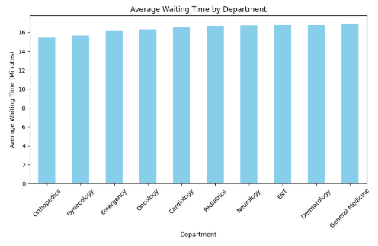
Doctor vs Patient Load Analysis
This analysis evaluates the number of patients handled by each doctor during the selected period.
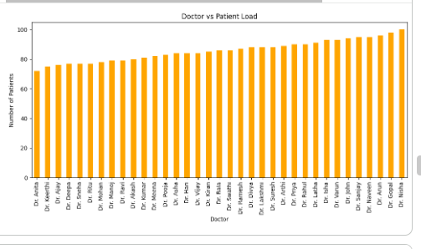
Emergency Cases vs Appointment Delays
This analysis investigates the relationship between emergency admissions and appointment delays.
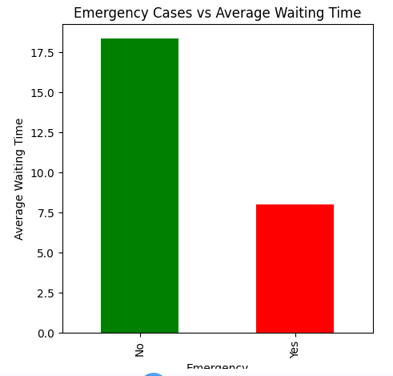

. Patient Satisfaction vs Waiting Time
This analysis examines the relationship between patient waiting time and satisfaction score.
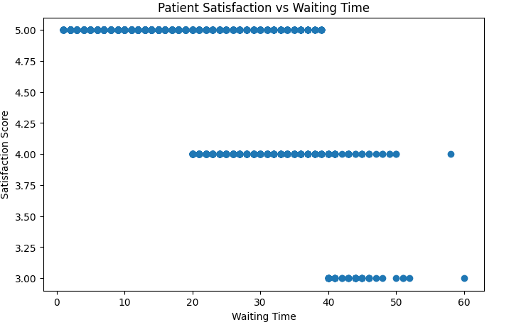
Bed Utilization Trends
This analysis monitors the occupancy status of hospital beds over time.
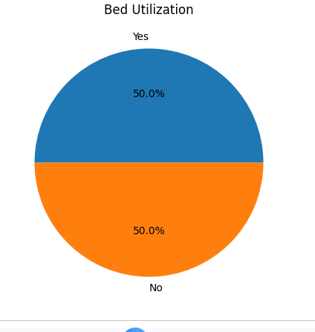
Correlation Analysis
A correlation matrix was created to measure the relationship between numerical variables in the dataset.
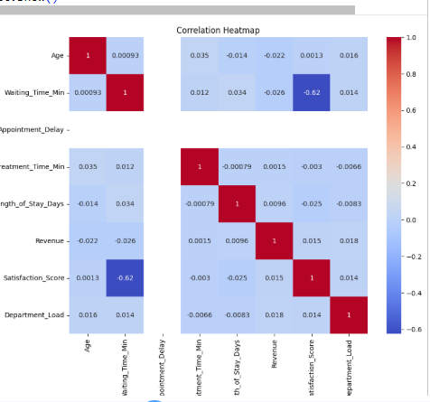
Trend Analysis
Patient admission trends were analyzed using admission dates to identify changes in patient volume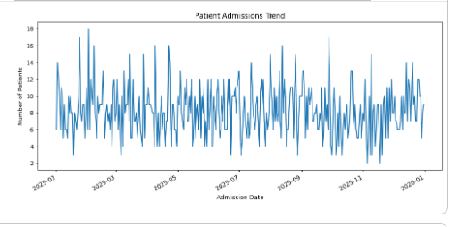
The relationship between waiting time and patient satisfaction was analyzed using a scatter plot. The analysis indicates that reducing waiting time can improve patient satisfaction and enhance the overall healthcare experience.
Which KPI is the most important?
"The most important KPIs are Total Patients, Average Waiting Time, Bed Utilization Rate, Patient Satisfaction Score, and Revenue Generated because they directly measure hospital efficiency, resource utilization, and patient experience."
Why did you analyze waiting time?
Waiting time is a key indicator of hospital service efficiency. Reducing waiting time improves patient satisfaction, optimizes hospital workflow, and enhances the overall quality of healthcare services."
These answers match the questions given in your task PDF and are appropriate for both your report and project presentation.
PHASE 4 – DASHBOARD DEVELOPMENT
The final phase of the project involved developing an interactive dashboard using Microsoft Power BI. The dashboard was designed to present healthcare data in a simple, visual, and user-friendly manner. It enables hospital administrators to monitor hospital operations, evaluate department performance, analyze patient flow, and assess patient satisfaction. The dashboard consists of four pages, each focusing on a specific aspect of hospital performance. Interactive slicers were included to allow users to filter and analyze data dynamically based on different criteria.
Dashboard Objectives
The primary objectives of the dashboard are:
- To provide a centralized view of hospital performance.
- To monitor key healthcare KPIs.
- To analyze patient flow and department activities.
- To evaluate hospital operational efficiency.
- To improve patient experience through data-driven insights.
- To support management in making informed decisions.
Executive Overview Dashboard
The Executive Overview Dashboard provides a summary of the hospital's overall performance by displaying key performance indicators and essential visualizations. It gives hospital administrators a quick understanding of the current operational status.
KPIs Displayed
- Total Patients
- Revenue Generated
- Average Waiting Time
- Patient Satisfaction Score
Visualizations Used
- Revenue by Department (Bar Chart)
- Average Waiting Time by Department (Column Chart)
- Patient Admission Trend (Line Chart)
- Interactive Slicers (Department, Gender, Emergency, Shift)
Purpose
This dashboard helps management monitor overall hospital performance and identify important trends without analyzing individual reports. 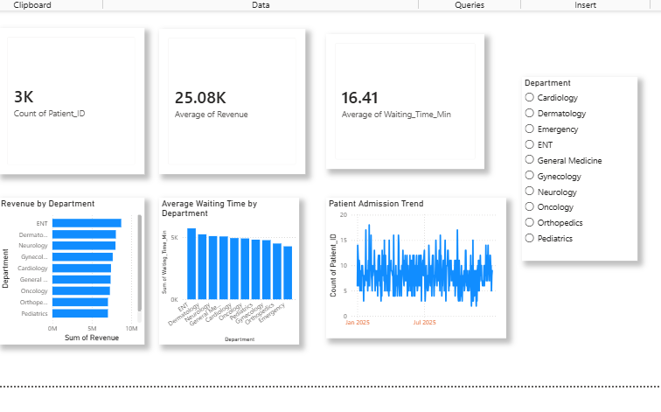
Patient Flow Dashboard
Description
The Patient Flow Dashboard focuses on patient movement within the hospital. It analyzes admission patterns, department activity, and peak-hour patient load to understand how patients move through different hospital services.
Visualizations Used
- Patient Admission Trend (Line Chart)
- Department Activity (Bar Chart)
- Peak Hour Patient Load (Column Chart)
- Visit Type Distribution (Donut Chart)
Purpose
This dashboard assists hospital administrators in identifying busy departments and peak admission periods, allowing them to allocate staff and hospital resources more efficiently.
Patient Flow Dashboard
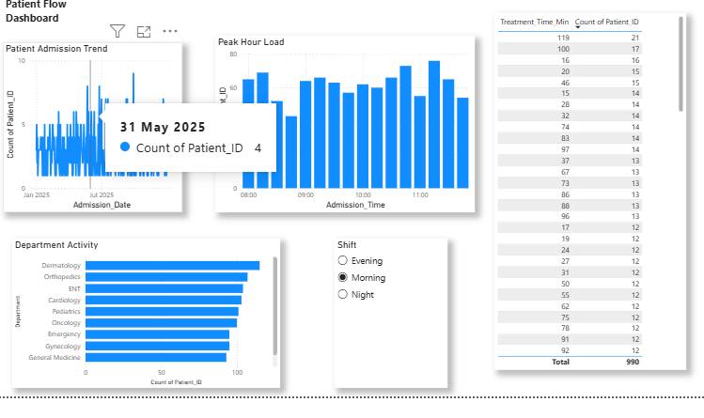
8.5 Operational Dashboard
Description
The Operational Dashboard evaluates hospital operational efficiency by analyzing doctor utilization, bed occupancy, revenue generation, and treatment duration.
Visualizations Used
- Doctor Utilization (Bar Chart)
- Bed Occupancy (Donut Chart)
- Revenue by Department (Column Chart)
- Average Treatment Time (Bar Chart)
Purpose
This dashboard enables hospital management to optimize doctor workload, monitor hospital resources, and improve operational efficiency.
Operational Dashboard
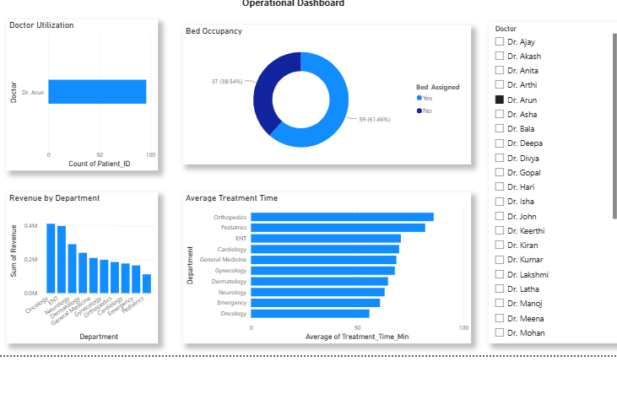
Patient Experience Dashboard
Description
The Patient Experience Dashboard focuses on evaluating the quality of healthcare services from the patient's perspective. It analyzes satisfaction levels, waiting time, service quality, payment methods, and treatment outcomes.
Visualizations Used
- Patient Satisfaction by Department (Bar Chart)
- Waiting Time vs Satisfaction (Scatter Plot)
- Service Quality Distribution (Donut Chart)
- Payment Mode Analysis (Column Chart)
- Treatment Outcome Distribution (Pie Chart)
Purpose
This dashboard helps management understand patient experience, identify factors affecting satisfaction, and improve healthcare service quality.
Patient Experience Dashboard
Dashboard Features
The Power BI dashboard includes several interactive features to improve data exploration and analysis.
- Interactive KPI Cards
- Bar Charts
- Column Charts
- Line Charts
- Pie Charts
- Donut Charts
- Scatter Plot
- Slicers for filtering data
- Dynamic visualizations
- User-friendly interface
These features allow users to analyze hospital data efficiently and make better operational decisions.
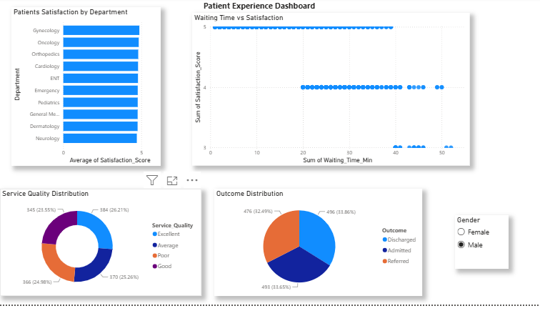
BUSINESS RECOMMENDATIONS
Based on the analysis performed in this project, the following recommendations are proposed to improve hospital operations and enhance the quality of healthcare services. Reduce Patient Waiting Time
Hospital management should improve appointment scheduling and patient flow to reduce waiting times. Additional medical staff can be allocated during peak hours to ensure patients receive timely treatment.
Improve Department Efficiency
Departments experiencing high patient loads or longer waiting times should be monitored regularly. Hospital administrators can allocate additional doctors, nurses, and support staff to these departments to improve operational efficiency.
Optimize Bed Utilization
Bed occupancy should be monitored continuously to ensure that beds are available when needed. Efficient bed management helps reduce patient waiting time for admission and improves hospital resource utilization.
Enhance Emergency Response
Emergency departments should maintain sufficient medical staff and resources to handle critical cases efficiently. Proper emergency planning can reduce treatment delays and improve patient outcomes.
Improve Patient Satisfaction
Patient feedback should be collected regularly to identify areas requiring improvement. Reducing waiting time, improving communication, and maintaining high service quality can significantly enhance patient satisfaction.
Monitor Hospital Performance Using KPIs
Hospital administrators should regularly monitor key performance indicators such as Total Patients, Average Waiting Time, Bed Utilization Rate, Revenue Generated, Emergency Cases, and Patient Satisfaction Score. Continuous monitoring supports better decision-making and improves hospital performance.
Use Data-Driven Decision Making
Healthcare organizations should adopt data analytics tools such as Python and Power BI to monitor hospital operations, identify performance trends, and make informed decisions based on real-time data.
CONCLUSION
The Smart Hospital Analytics Dashboard project successfully demonstrated how healthcare data can be analyzed and visualized to improve hospital management and operational efficiency. The project began with data understanding and cleaning, where the hospital dataset was prepared for analysis by handling missing values, removing duplicates, converting date and time fields, and creating derived features.
Healthcare Key Performance Indicators (KPIs) were then designed to measure important aspects of hospital performance, including patient volume, waiting time, bed utilization, patient satisfaction, emergency cases, department performance, and revenue generation. Analytical investigations were carried out using charts and visualizations to identify trends, relationships, and operational bottlenecks.
Finally, an interactive Power BI dashboard was developed to present the analysis through four dedicated dashboard pages: Executive Overview, Patient Flow Dashboard, Operational Dashboard, and Patient Experience Dashboard. These dashboards provide hospital administrators with a clear view of hospital operations and support effective decision-making.
Overall, this project demonstrates that integrating Python for data preprocessing and Power BI for visualization provides an effective solution for healthcare analytics. The dashboard enables hospitals to improve operational efficiency, optimize resource utilization, reduce waiting times, enhance patient satisfaction, and support data-driven management decisions. The project highlights the importance of business intelligence tools in modern healthcare and their role in delivering better patient care.

